Just for Middle Schoolers!

An opportunity to try something new
- 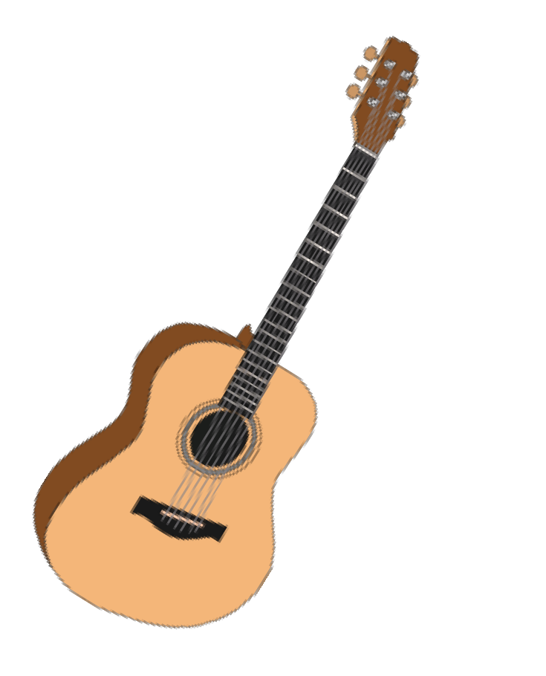Only a six-week commitment
- FREE!! All equipment, materials provided
- Have fun
- Make new friends
Check this out!
This six-week session will offer six exciting experiences:
- Cooking Thursdays 5:30 – 7:00pm
- Photography (Advanced2) Mondays 5 – 6:30pm
- Boxing Thursdays 6:00 – 7:00pm
- Guitar Mondays 6:30 – 7:30pm
- Bowling (Beginning) Fridays 4:00 – 5:00pm
- SafeSitters Saturday Oct. 5, 9:00am – 4:00pm

When:
SIGN UP BY CALLING First Presbyterian CHURCH OFFICE AT 317-398-8224
OR fax your enrollment form to 317-398-4206

**All classes START the week of September 9 and continue through October 25 (classes may or may not meet during Fall Break). **

Friday, Oct 25, 6:00-7:30 Free CELEBRATION! Dinner –
Bring family & friends and show off what you’ve accomplished!
See what’s next -- Sign up for more!

Where:
First Presbyterian Church, 124 West Broadway St. (except as noted)
TO REGISTER OR FOR MORE INFO: CALL THE CHURCH OFFICE AT 317-398-8224

Course Details Fall 2019, Session 1

Cooking – Open to all experience levels. Learn how to use the kitchen to prepare a variety of more elaborate homemade dishes. Also learn more about meal planning, nutrition and shopping for groceries. Plus, you get to EAT what you make! Led by Pastor Mark (chef extraordinaire). If you enjoyed beginning cooking, you’re sure to enjoy learning to make some really great dishes and meals. All cooking will be done at the church in the basement kitchen. Thursdays, 5:30 – 7:00 at First Presbyterian.

Advanced Photography – This class is open to anyone who has completed the Photography I class or can demonstrate basic skills with a digital camera. Participants will learn advanced techniques of making photographs – composition, lighting, advanced camera techniques, tripods, etc. We will be doing some photo shoots around Shelbyville, but we’ll also be travelling to other locations to broaden our subject matter. Significant class time will also be spent editing our work and learning how to use digital photography software. Class size is limited to 6 students. Classes meet at First Presbyterian Church. If you enjoyed Photography I, here is your chance to learn even more and advance your photo skills. Mondays 5pm – 6:30pm. Led by Mike Whitfield and Dyan Current.

Boxing – Learn the basics of boxing in the gyms at Trinity Methodist Church gym. Led by Jeremy Tillison, you will learn to use boxing equipment and how to condition your whole body to enjoy boxing. This is a really fun class open to both girls and boys. Thursdays 6:00 – 7:00pm.

Guitar – We provide the guitar; you make the music. This course is open to beginners as well as those wanting to continue their learning. We will work on playing notes and chords. You will be allowed to take the guitar home with you each week so you can practice at home. While some instruction will be small groups based on skill level, we will also work on playing as a larger group. Sheet music will be provided. Guitar is led by Roger Palmer, Fred Wittekind, Liz Wheeler & Holden Stephens. Class meets Mondays 6:30 – 7:30pm at First Presbyterian Church in the Choir Room on the main floor.

Safe Sitters – This class is a national certification class that teaches middle schoolers how to be a great baby sitter. This is a one day class, Saturday, Oct. 5, 9:00am – 4:00 PM with lunch provided. Students who complete the class successfully will receive a certification from Safe Sitters. There will be a graduation ceremony at the end, and parents are invited to come at 3:30 for the ceremony. Not only does Safe Sitters train you, but the certification may help you get more child care jobs and help you earn more money. Class will be taught by Dawn Whitfield, Registered Pharmacist and mom/Nana and Cynthia Morningstar. This class is open to both boys and girls. Class size is limited to 8 participants.

Bowling for Beginners – You’ve probably tried bowling, but here’s your chance to learn the proper techniques to become a good bowler. Open to all skill levels. Classes will be at the Blue River Bowling Lanes on South Miller Street. Jeremy McIntire and Will Mitchell will be supervising. Fridays, 4:00 – 5:00pm.

Sign up by calling First Presbyterian Church at 317-398-8224 Or faxing the enrollment form to 317-398-4206

More Info for Parents

The Opportunity Zone is a ministry of First Presbyterian Church and is developed and designed to encourage middle-schoolers to try something new and explore new interests. We know many middle-schoolers do not have these types of opportunities or can’t afford to pay for them. We believe that middle school is an important time in the transition from childhood to adult. Kids need to know they have gifts and are appreciated for who they are and what they can contribute to their family and community.

Opportunity Zone is available at no charge to participants and all equipment and supplies are furnished for each session. Since it is only a six-week commitment, kids can try something out and see if they like it. When they find something they love, we will help them develop their skills in that activity. Our hope is that some of these children will find a new, life-long interest that helps them build their self-confidence, develop friendships and adult relationships, and see new possibilities for their future.

We ask only that the middle-schooler commit to attending every meeting during the six weeks if possible, come on time and participate in their group. Parents are asked to drop off and pick up their children on time. We may be able to assist with transportation in certain situations.

We also encourage parents or guardians, siblings and friends to come to the celebration dinner on Friday, Oct. 25, 6:00 to 7:30. The kids will be demonstrating what they have learned, and we can share a meal and discuss future events. We want the kids to be able to celebrate with their family and friends and have a fun evening together.

Each activity is led by at least two adults who have been trained to work with middle schoolers. Kids will be supervised by adults at all times. The groups are kept small with an appropriate ratio of adults to kids. Parents or family are encouraged to meet the leaders and discuss the activities with them at any time. We also appreciate all suggestions for improvement, new activities or ideas. If you have a hobby or activity you love and want to share what you have learned, please talk to us! We are looking for new classes and volunteers.

Thank you for allowing your child to participate. Please call the church at 317-398-8224 if you have any questions, suggestions or need more information.

Registration
Name:
Address:

Your Cell Phone# Your email:

Please List your First and Second choices of classes for the Fall 2019 session:

1

Your birth date
Emergency Contacts:
Grade

2

- Name: Relationship to you Cell phone
- Name: Relationship to you Cell phone
Any medical info (allergies, medications you carry):

Do you have transportation to and from meetings?
Yes No

You may mail this form to First Presbyterian Church, 124 W. Broadway St, Shelbyville, 46176 OR fax your registration to at 317-398-4206 OR call the church at 317-398-8224.

Your activity leader will contact you before the first meeting to confirm and answer any questions.

Please enter through the alley entrance – door will be unlocked 15 minutes before the start time.

HAVE FUN!!!

